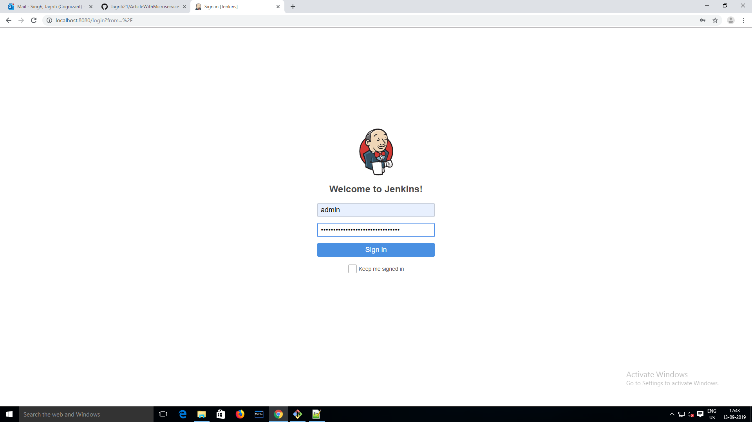

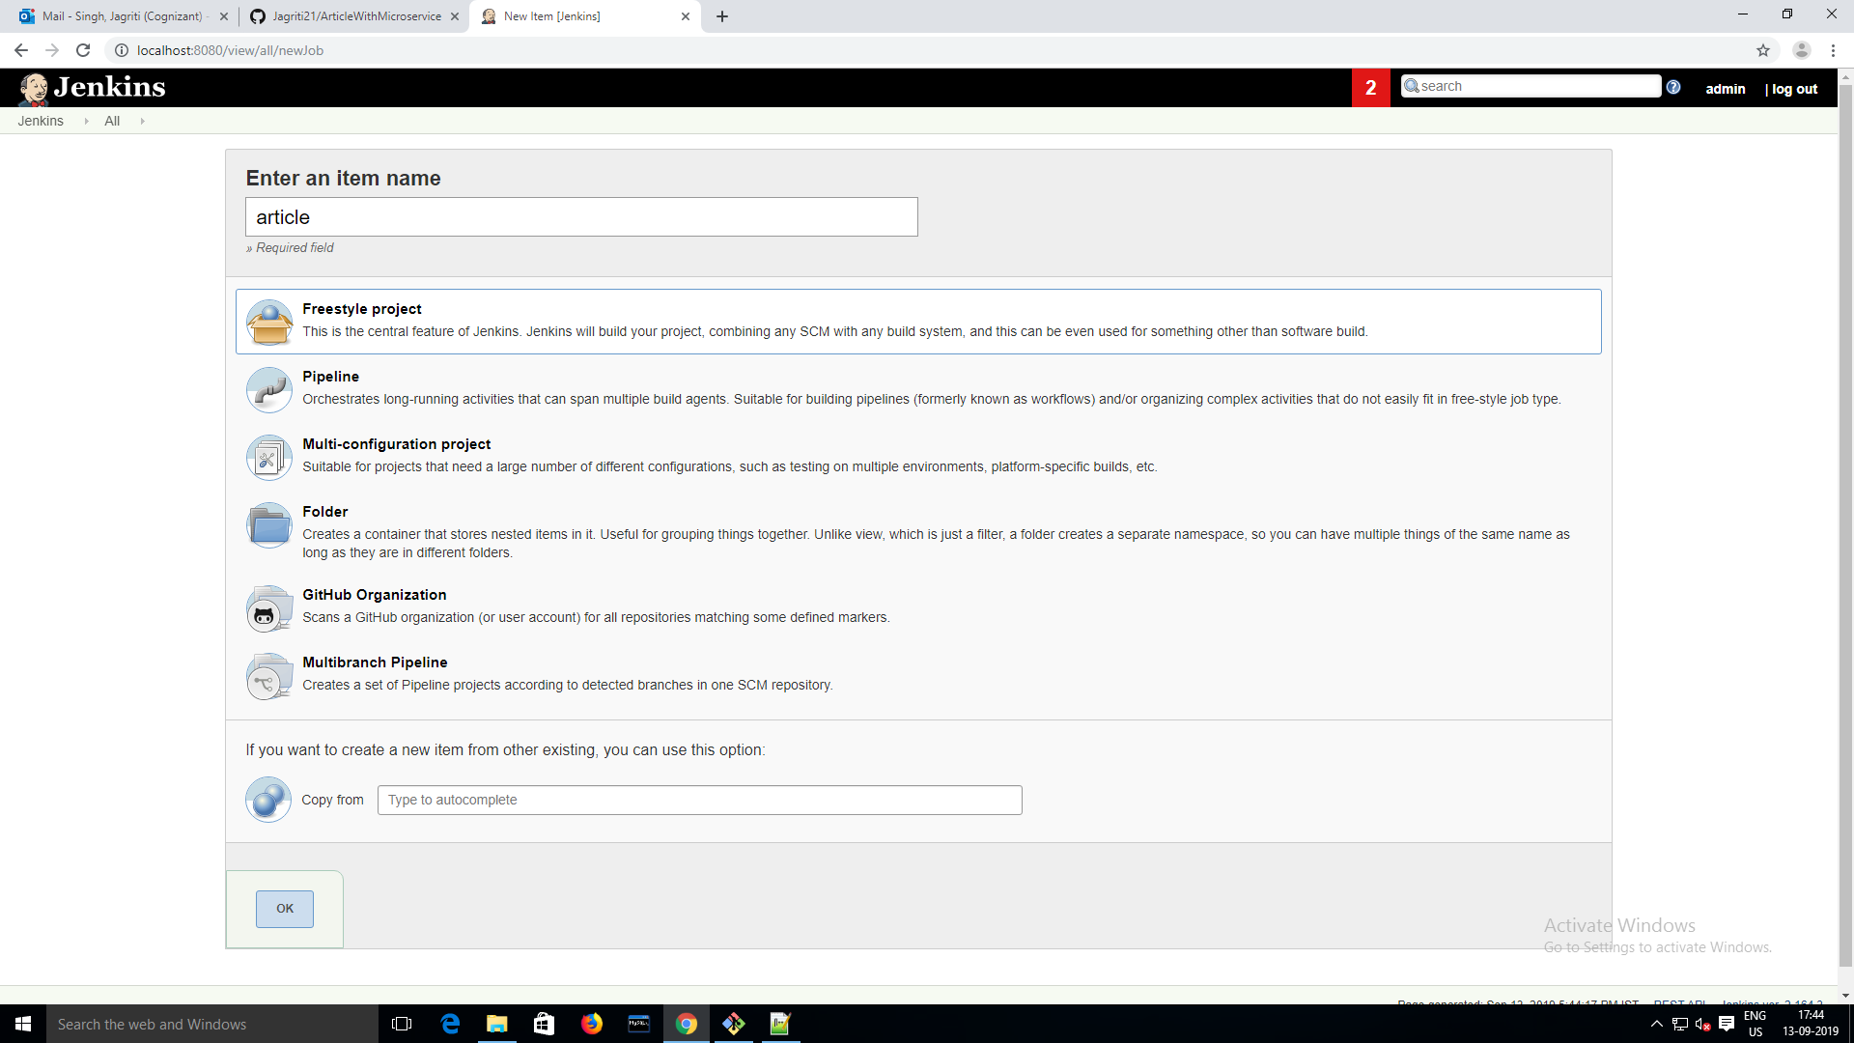

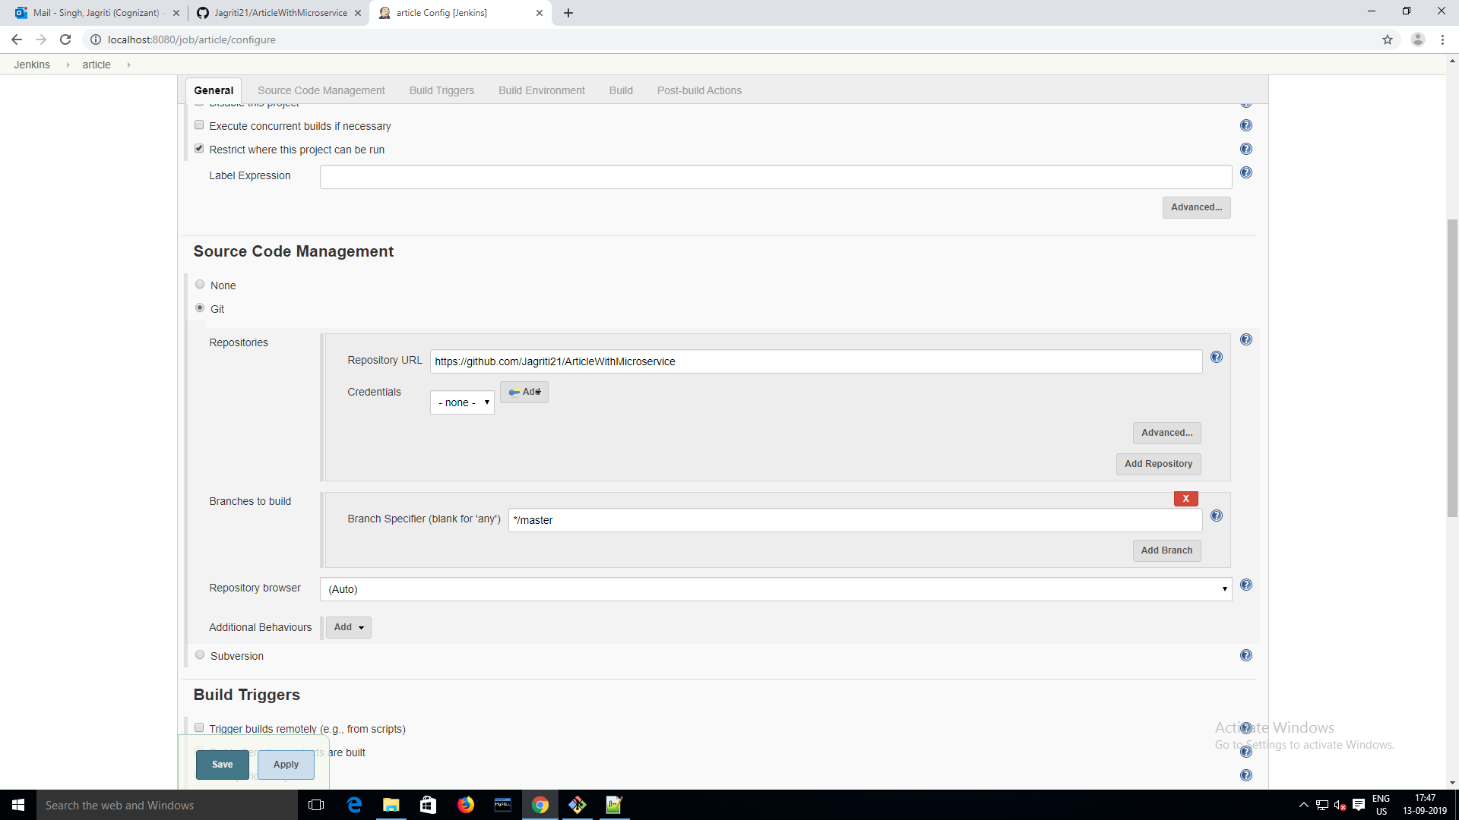

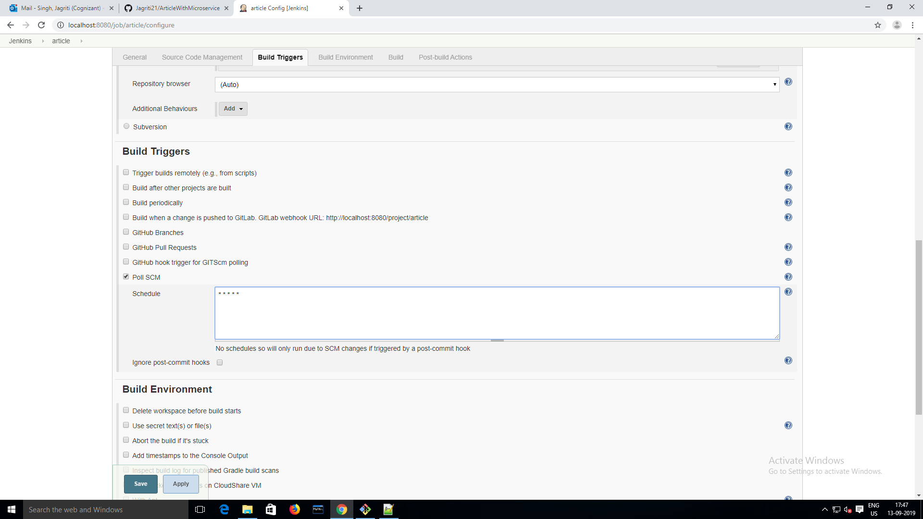

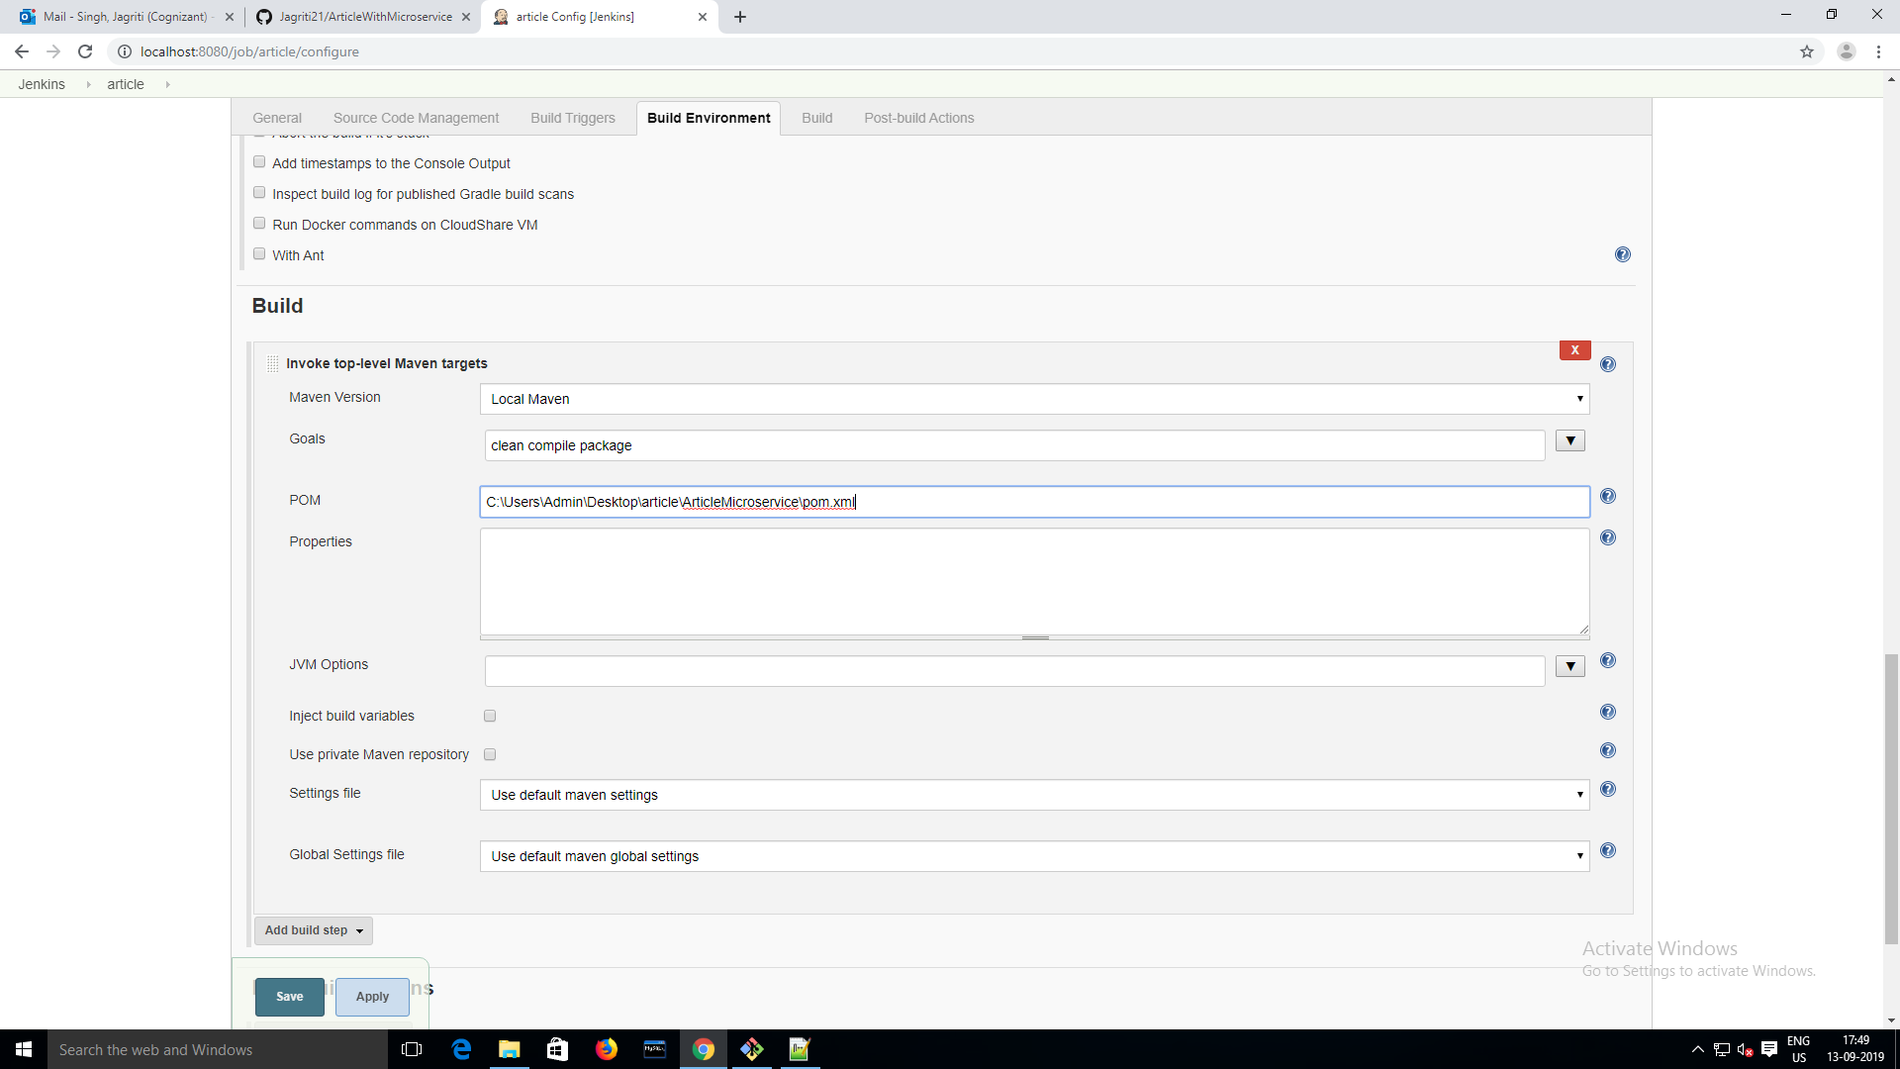

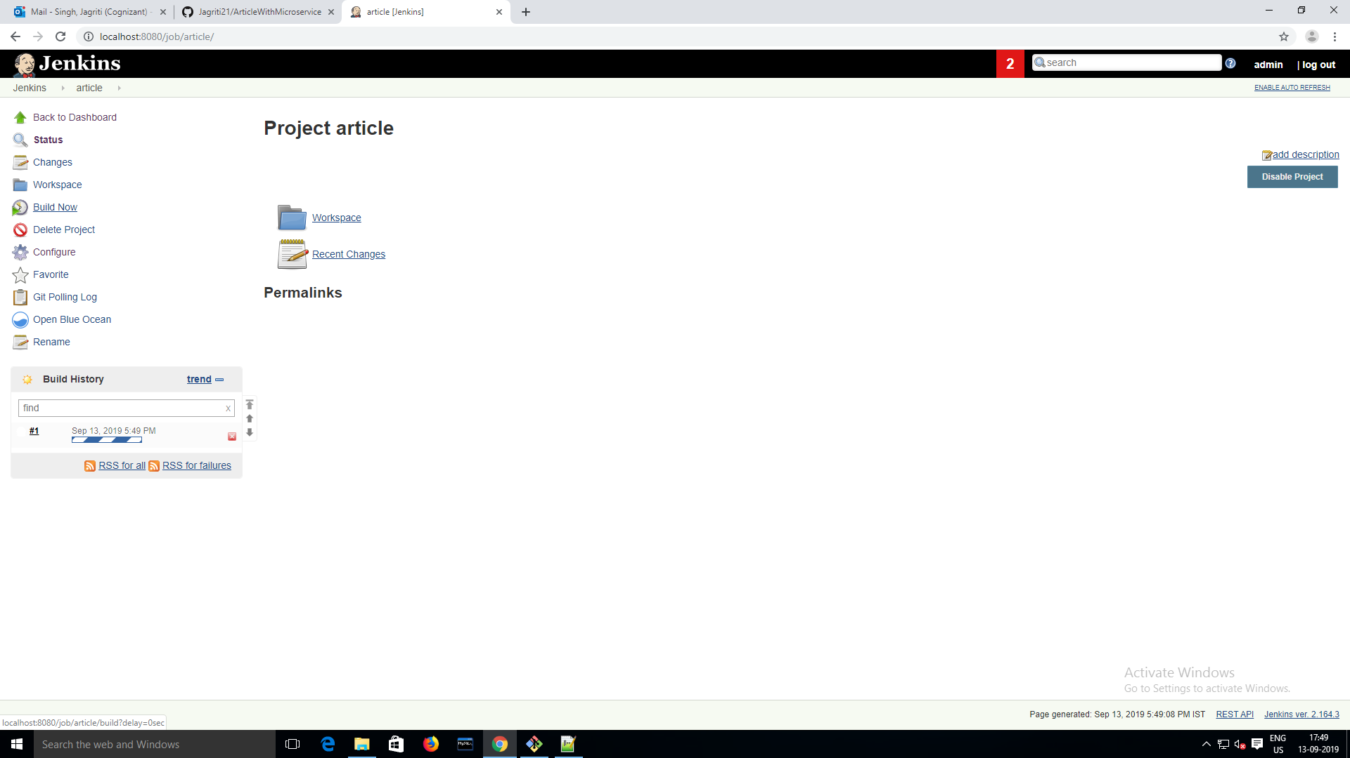

Build got failed 3 times then I add this plugin to pom.xml

<plugins>

<plugin>

<groupId>org.apache.maven.plugins</groupId>

<artifactId>maven-surefire-plugin</artifactId>

<version>2.19.1</version>

</plugin>

</plugins>

